
CDOC Survivorship Workgroup presents
Key CA Financial Cancer Resources
June 2023

Presenters
- Triage Cancer oMonica Bryant
- Cancer Legal Resource Center oShelly Rosenfield
- Health Options
oPatricia Falconer

WEBINAR CURRICULUM
I. Employment & Disability
II.Understanding Insurance Coverage Options
- Understanding How to Choose the Best Insurance Options
- Managing Medical Bills and Medical Appeals
- Financial Assistance Programs
- CA Cancer Resource Hub

Employment & Disability
What is the CLRC?
Our mission: To provide information & resources on cancerrelated legal issues to cancer patients, survivors, caregivers, healthcare professionals, employers, and others coping with cancer.

(c) Disability Rights Legal Center 2023

Employment & Disability
Request accommodations before your work performance is affected

(c) Disability Rights Legal Center 2023

Americans with Disabilities Act (ADA)

Works to protect from discrimination at all phases of employment

Americans with Disabilities Act

Employers:
- State & Local Govt.
- Private if 15+ employees
Employees:
- Must have a disability o Physical or mental impairment o That substantially limits a major life activity
- Must be qualified (can perform essential functions of job with or without accommodations)
If qualified, employee is protected from discrimination and entitled to reasonable accommodations
(c) Disability Rights Legal Center 2023

Reasonable Accommodations

- Any change or adjustment in the work environment, or in the way things are customarily done, that enables an individual with disabilities to enjoy equal employment opportunities.
- Examples: work from home, flexible/change in schedule, assistive equipment, reassignment of non-essential job duties, etc.

California Fair Employment & Housing Act

- Definition of disability broader than ADA
o(specifically lists cancer)
- Applies to employers with at least 5 employees
- Limitation on major life activity

If You Suspect Discrimination In Employment

Contact an employment law (or labor law) attorney right away to discuss whether it makes sense to:
- File a complaint with DFEH
- File a complaint with EEOC
- File a lawsuit

Employment & Disability
You may be able to take time off and keep your job!


Family and Medical Leave Act (FMLA)

12 Weeks of UNPAID job and health benefit-protected leave per year to:
- Take care of self Or
- Covered family member

“Covered EMPLOYER”

- ALL Public Employers
(Local/State/Federal)
- SOME Large Private Employers (Have 50+ employees in 75 mile radius)

“Covered EMPLOYEE”
Employee must have worked for:

- 12+ months AND
- 1,250+ hours in the last year

Substitution of Paid Leave

While on FMLA…
Employee can choose
OR employer can require use of vacation or sick leave
Not Enough Time Off? Not Qualified for FMLA?

- Check employer’s policy
- Request time off as an accommodation under ADA or state law
Note: Employers do not have to hold a position open indefinitely.

Understanding Insurance Coverage
Options

Understanding Health Insurance
Cost to Have Health Insurance
- Premium – each month (fixed $ amount)
Costs When You Use Your Health Insurance
- Deductible – each year (fixed $ amount)
- Co-Payment – each time you get care (fixed $ amount)
- Co-Insurance or Cost-Share – each time you get care (%)
- Out-of-Pocket Maximum (fixed $ amount) = deductible + co-payments + co-insurance

© 2023 Triage Cancer®


Meet Dan
Dan’s Plan: Deductible = $2,000
Co-insurance = 80/20 plan
OOP Max = $8,000
If Dan has a $102,000 hospital bill, what does he pay?
- His deductible of $2,000
$102,000-$2,000 = $100,000 left
- His co-insurance amount of 20%
20% of $100,000 = $20,000
But OOP max is $8,000. So, he would only pay the $2,000 deductible + $6,000 of the $20,000 co-insurance amount, for a total of $8,000.
© 2023 Triage Cancer®

Where We Get Health Insurance
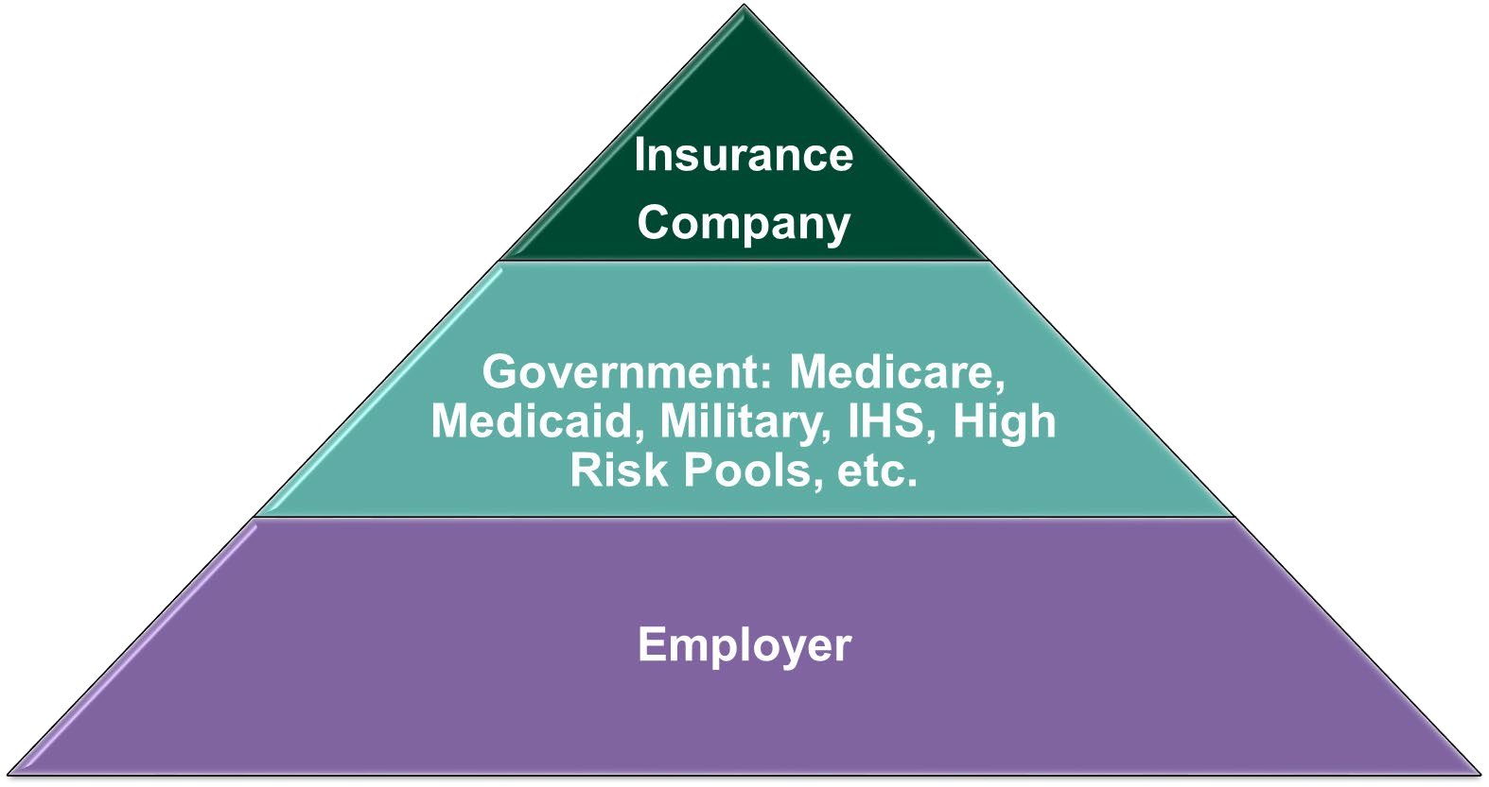
© 2023 Triage Cancer®

Understanding How to Choose the Best Insurance Options
Bronze: Monthly Premium | Deductible | Out-of-pocket Maximum
$200 | $6,000 | $8,000
Silver: Monthly Premium | Deductible | Out-of-pocket Maximum
$275 | $2,500 | $6000
Platinum: Monthly Premium | Deductible | Out-of-pocket Maximum
$400 | $0 | $2000

How to Choose the Best Health Insurance
© 2023 Triage Cancer®

How to Choose the Best Health Insurance: Do The Math
Total possible costs for year = 12 months of premiums + OOP max
Bronze Plan:
$200x12 = $2,400
+
OOP = $
8,000
Total = $10,400
Silver Plan:
$275x12 = $3,300 +
OOP = $6,000 Total
=
$
9,300
Platinum Plan:
$400x12 = $4,800
+
OOP = $
2,000
Total = $6,800

How to Choose the Best Health Insurance: Not Just the Math
- Cost
- Premiums, co-payments, deductibles, co-insurance, out-of-pocket maximums
- Network of providers and facilities
- Check to make sure your providers and facilities (hospitals, labs, imaging centers, etc.) are covered by the plan you choose
- Prescription drug coverage
- Which drugs are covered (i.e., formulary)?
- Prior authorization or step therapy?
- Are there separate out-of-pocket costs (e.g., co-payments, co-insurance, deductibles, out-of-pocket maximum)?
© 2023 Triage Cancer®

Making the Most of Your Plan
- Using in-network providers
- Ask for pre-authorizations
- Paying attention to bills o Billed for what you received o Preventive services
- Leveraging out of pocket maximums o Other needed medical care o Timing/scheduling o Family OOP Max
- Appealing denials

Health Insurance Appeals
- Denials of coverage (aka “adverse benefit determination”
(ABD))
- Internal appeals
- External appeals (individual and employer plans) o AKA: Independent or External Medical Review
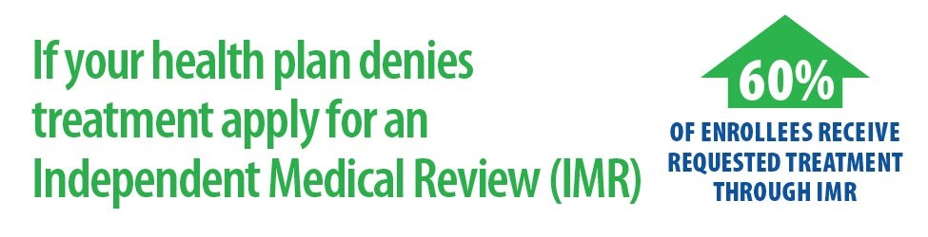
o Conducted by an independent medical review organization (IRMO) or independent review entity (IRE*) o State Health Insurance Agency
▪ Triagecancer.org/StateResources

Health Insurance Appeals
Gather Evidence of “Medical Necessity”
- Letter of support from your HCP
- Notes from your HCP on medical care
- Results of tests/procedures related to the requested care
- Current medical literature, studies, or other professional journals documenting the medical effectiveness of the requested services for experimental or investigational treatments (www.pubmed.gov)
- Personal narrative describing the need for the requested service
- Find out if the denial was made by an oncologist who works for the insurance company versus another type of doctor
- Any other medical records

Appeals Hurdles: Staying Organized
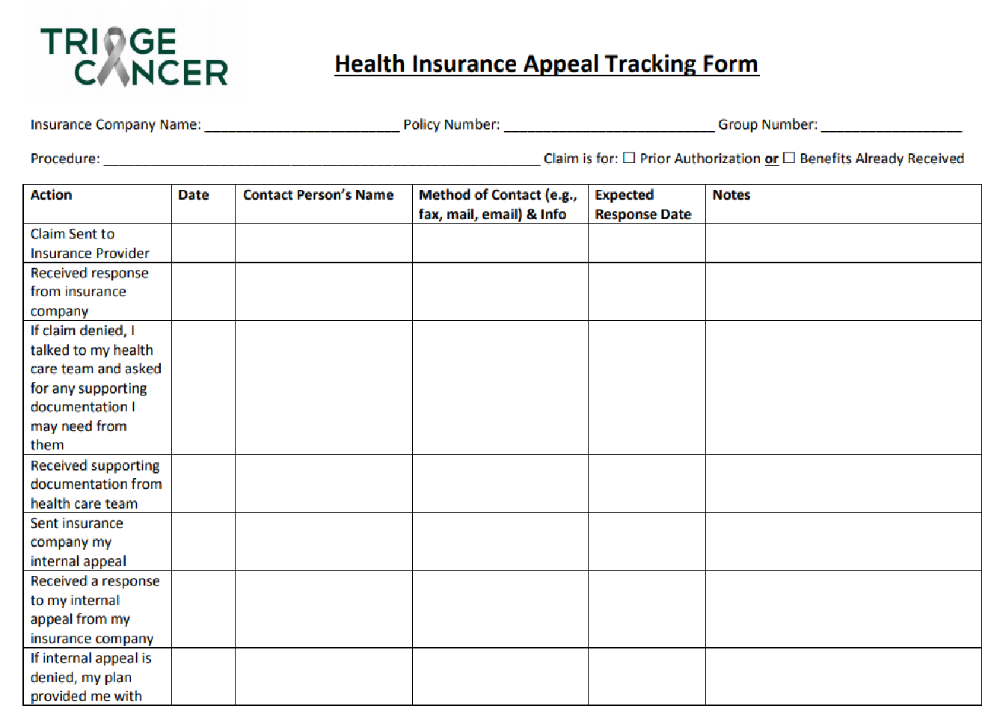
- Keep track of:
o Dates, times, and method of any contact
(phone, email, etc.) o Names of people you talk to o Summaries of your conversations o Any documents you send or receive o Important dates
- Good time to delegate to family & TriageCancer.org/AppealTrackingForm friends

Appeals Hurdles: Knowledge
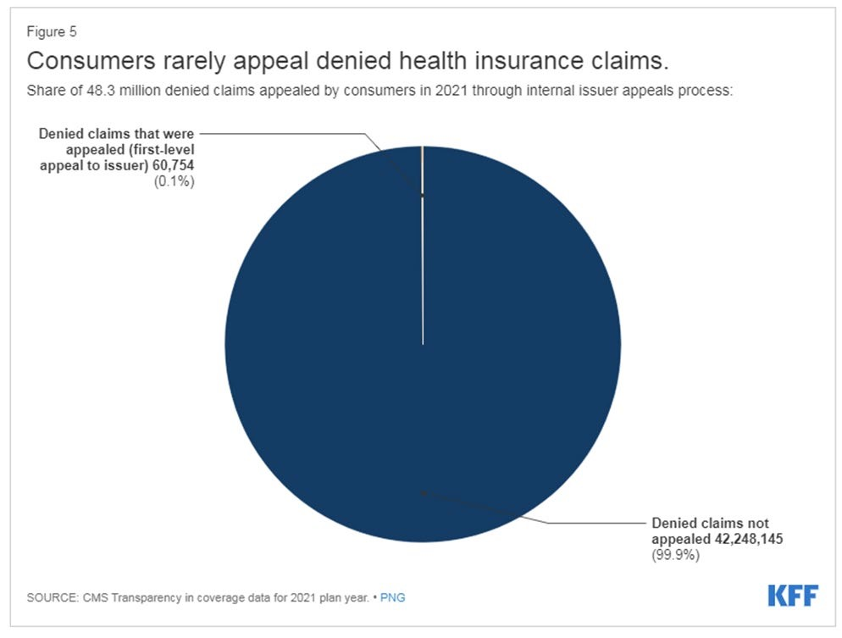
© 2023 Triage Cancer®

Health Insurance Appeals Checklist
- Understand why your claim was denied
- Gather your evidence
- Submit necessary paperwork
- Pay attention to deadlines
- Remember the Golden Rule
- File External Appeal ifneeded
- Expedite Appeal ifappropriate
- Stay organized  Don’t give up!

Dealing with Medical Bills

Dealing with Medical Bills
Communications from insurance company:
We have
received a
claim
We are
processing
your claim
Explanation
of Benefits

Dealing with Medical Bills
From your provider:

- The bill
Doesn’t always happen in this order!
- Wait for the EOB before paying any bills
- Keep track and communicate with providers

Dealing with Medical Bills
- Review bills for accuracy o Don’t be afraid to ask your provider to clarify codes!
  - Medical procedure billing codes: CPT (Current Procedural Terminology) codes, www.nlm.nih.gov/research/umls/sourcereleasedocs/current/CPT/sourcerepresentation .html
  - Medical diagnosis codes: International Classification of Diseases (ICD) codes, www.who.int/standards/classifications/classification-of-diseases
- Consider professional bill reviewer/medical claims org o Alliance of Claims Assistance Professionals (ACAP) www.claims.org
- Appeal any denials of coverage
- Apply for help with financial assistance o CancerFinances.org

Negotiate
Contact providers if having trouble paying your bills
- When:
  - Before unpaid bills sent to collections agencies
- What:
  - Ask for more time o Check to see if they would be willing to:
    - Write off a portion of your bill;
    - Negotiate a payment plan; or
    - Accept a lower lump sum payment Note: works with other creditors, too!

Financial Assistance Programs

Financial Assistance Programs
Many treatment plans for cancer diagnoses include high-cost drugs that are administered orally, via injection or infusion.
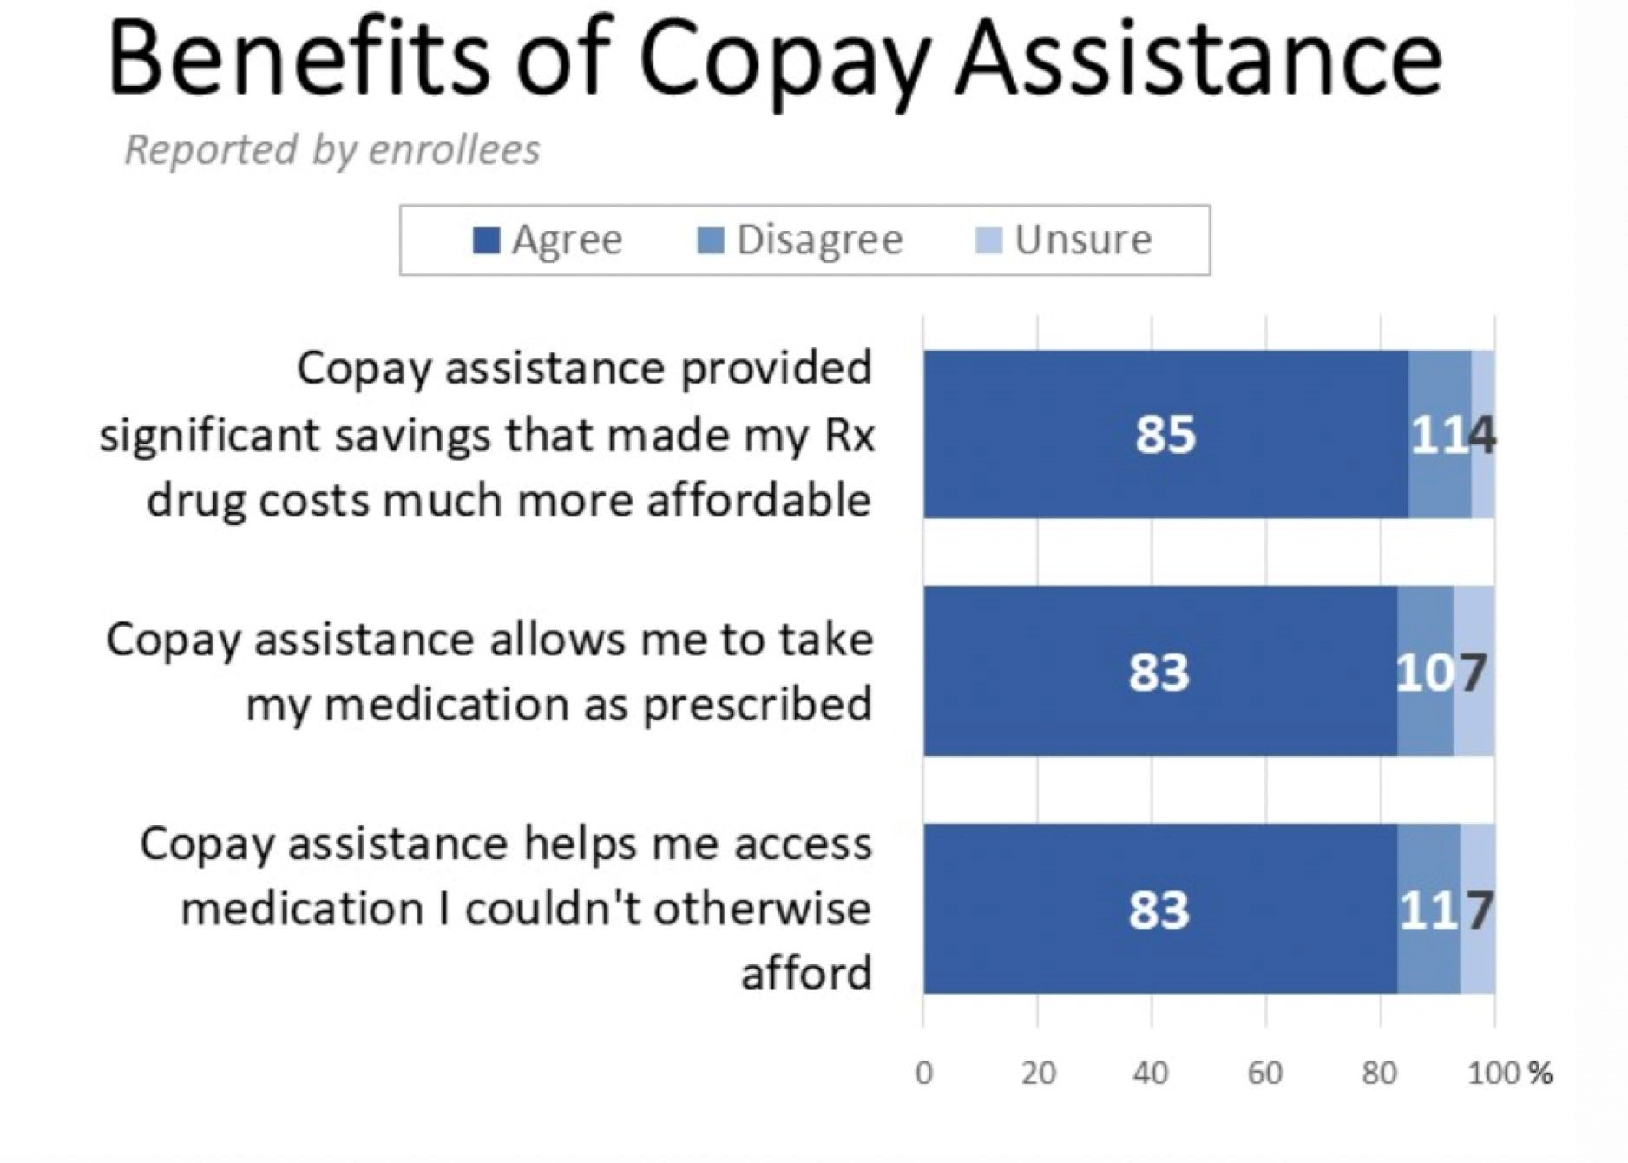

- Prescription drug costs are a challenge for nearly a third of cancer patients and survivors.
- Copay assistance programs can help ensure patients receive needed medications.
- Over half of cancer patients have heard of copay assistance but most have not tried to enroll in available programs.

Financial Assistance Programs
Direct Financial Resource Assistance Programs
- Drug Manufacturer Copay Assistance
- Charitable Foundation Copay Assistance
- Clinical Trial Assistance and Support Grants

Copay Assistance Programs: Drug Manufacturers
- Commercial Health Insurance
- Drug Name, Diagnosis, and Drug Manufacturer
- Eligibility requirements vary by drug manufacturer • Individual to live in or receive treatment in the U.S.
- Receive the drug for an FDA approved indication
- Not be receiving financial assistance for the specific drug from a co-pay charitable foundation.
- Often do not have a maximum family income threshold
- Require a small patient copayment
- Have an annual benefit cap
Patients must demonstrate proof of personal monetary responsibility by submitting documentation of paid claims (Remittance Advices or Explanation of Benefits) to trigger payments.

Copay Assistance Programs: Charitable Foundations
- Based on a physician verified diagnosis
- Confirmed patient responsibility
- Drug name, diagnosis, and drug treatment given in the U.S covered by the disease fund
- Have an income level most commonly at or below 400-500% of the Federal Poverty Limit (FPL).
Foundations can only help patients receiving treatment for indications for which there is an open disease fund with active funds available. Disease funds for high incidence cancers open and close very quickly.
Patients must demonstrate proof of personal monetary responsibility by submitting documentation of paid claims (Remittance Advices or Explanation of Benefits) to trigger payments.

Support Grants: Charitable Foundations
- Insurance Premium Assistance
- Transportation
- Housing & Lodging
- Utilities
- Food
- Childcare/Eldercare
- Clinical Trial Participation
Eligibility Requirements
- Have a household income that is at or below 600% Federal Poverty Limit (FPL)
- Be a U.S. citizen or permanent resident of the U.S. or U.S. territories
- Diagnosis confirmed by treating provider
- Diagnosis of an open fund
- Paid to the individual and/or creditors
- Clinical trial enrollment

CA Cancer Resource Hub
Survivorship Resource Repository through the California Cancer Resource Hub
Cal Cancer Resource Hub → Survivorship → Practical → Finances https://www.calcancer.org/en/practical/finances/
- Managing Insurance
- Managing Finances
- One-on-One Help Understanding & Managing Finances
- Direct Financial Resource Assistance
- Health and Social Care Providers and Advocates



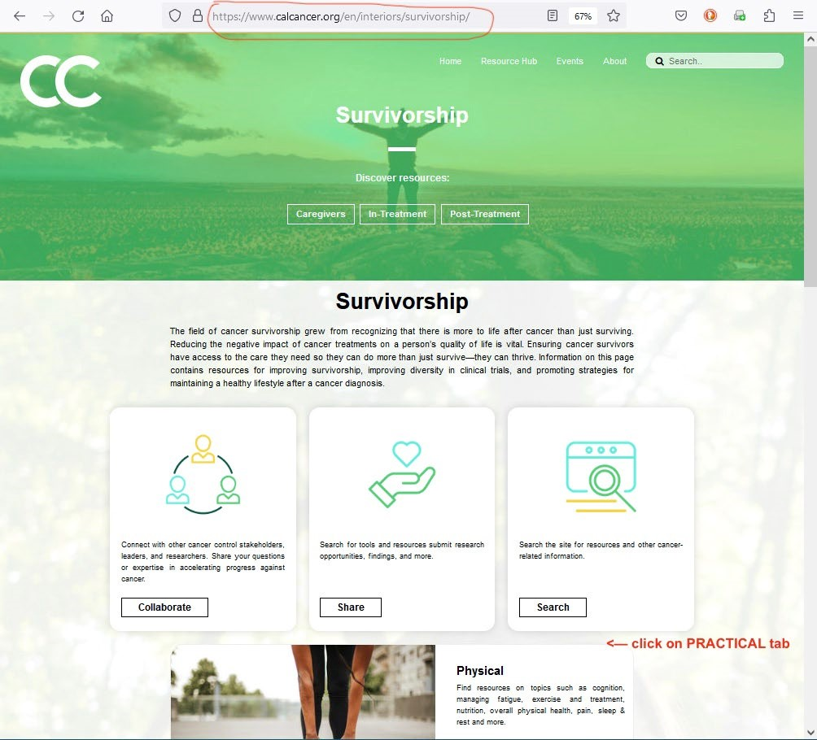

click on Practical tab




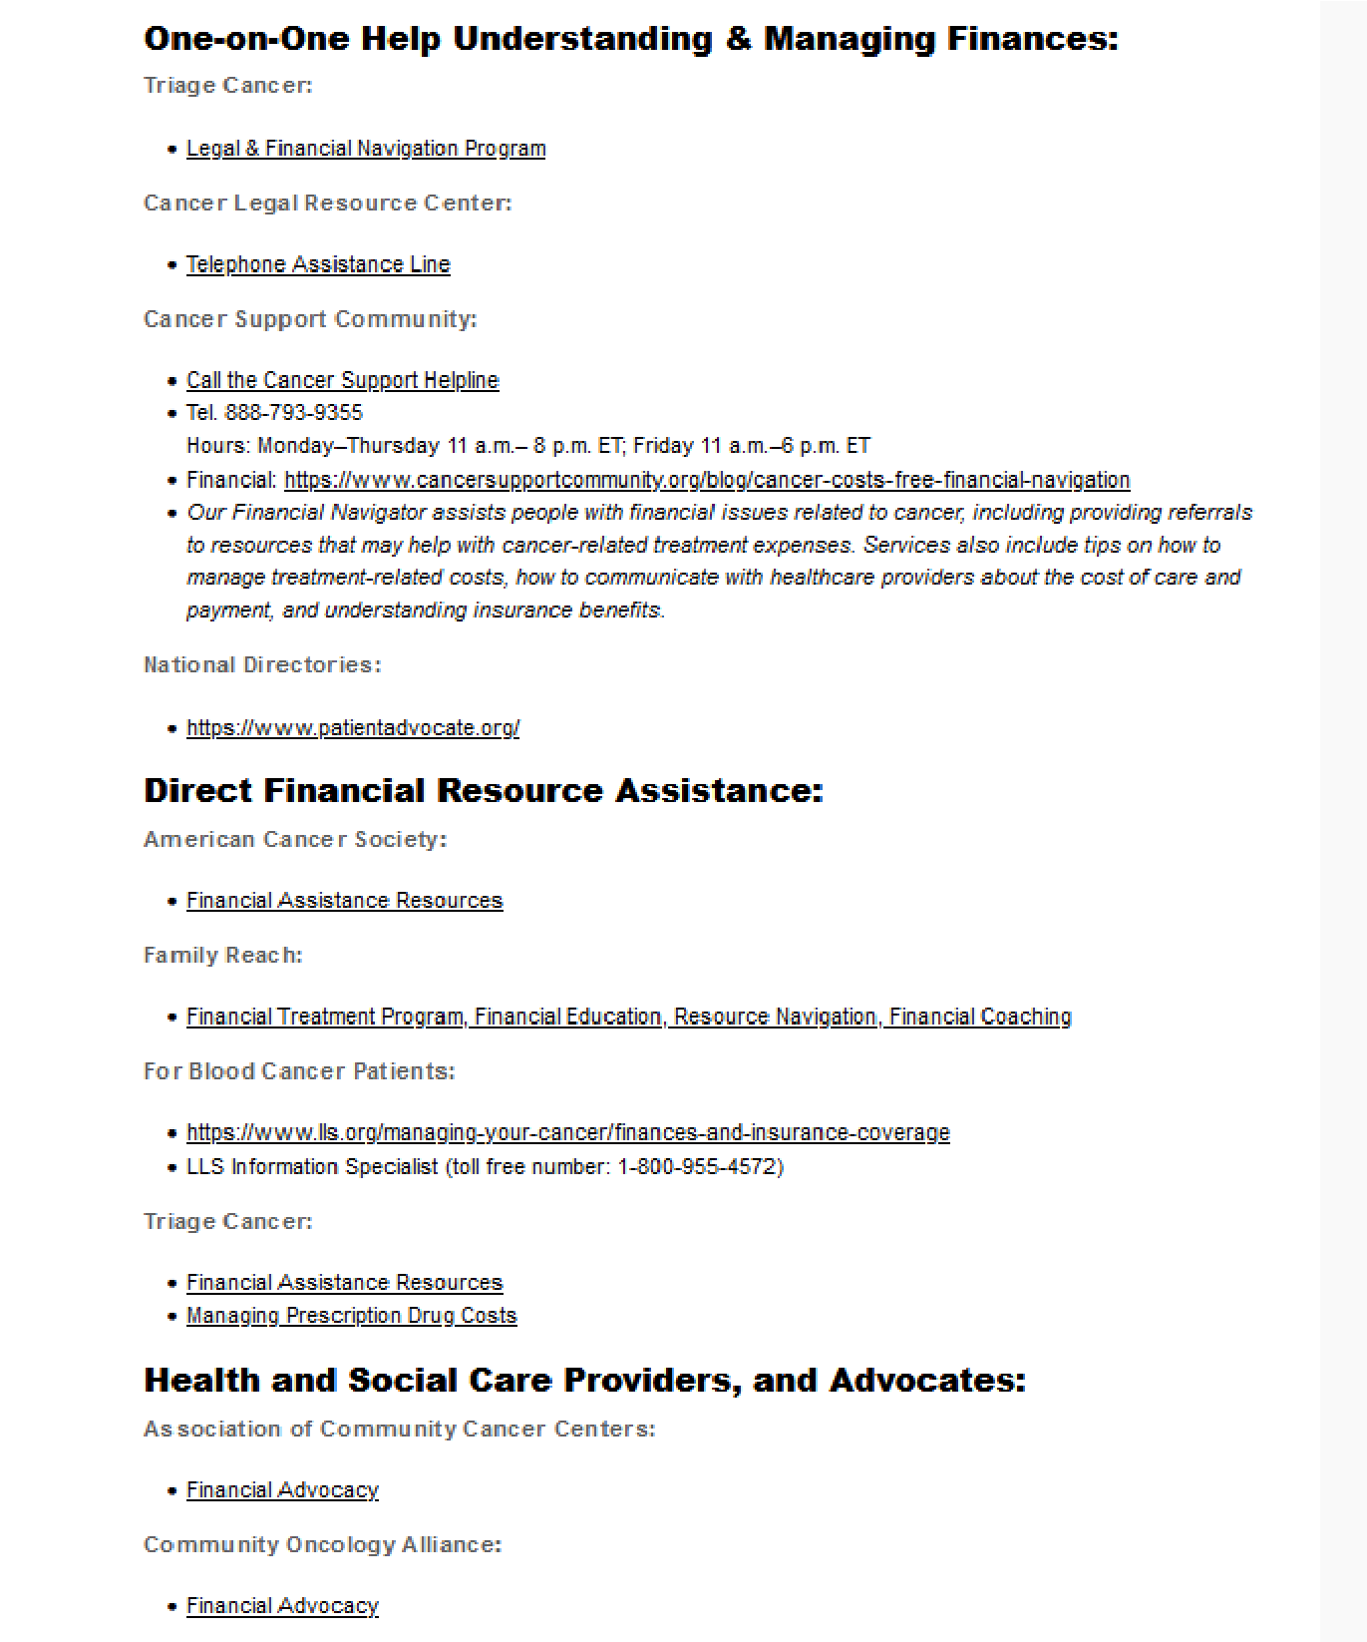
Other FINANCES subcategory

Thank you CDOC Survivorship

Workgroup!
- Catherine Thomsen, MPH - Zero Breast Cancer
- Cathleen Zoller - American Cancer Society
- Darcie Green, BCPA - Latinas Contra Cancer
- Elizabeth Klein - Wellness Within Cancer Support Services
- Florence Kurttila - Patient& Research Advocate
- Hilary Gan - Teen Cancer America
- Jennifer Aldred - UC Davis Medical Center, Sutter
Health
- Joanna Fawzy Morales, Esq - Triage Cancer
- Karissa Gutierrez - American Cancer Society
- Kelli Sargent - Tower Cancer Research Foundation
- Keren Stronach, MPH – UCSF Helen Diller Family Comprehensive Cancer Center
- Liisa Russell, MD - Touro University
- Lihua Liu, PhD - Keck School of Medicine, USC
- Maria Garcia-Jimenez, MD/MHS - UCLA David Geffen School of Medicine
- Megan Kelly - Tower Cancer Research Foundation
- Niharika Dixit – UCSF
- Patricia Falconer, MBA - Health Options
- Rob Tufel, MSW, MPH – Cancer Support Community San
Francisco Bay Area
- Roxanne Garza, MPH, CHES - The Leukemia & Lymphoma Society, Southern California & Hawaii Region
- Shelly Rosenfeld, Esq - Disability Rights Legal Center’s Cancer Legal Resource Center (CLRC)
- Wendy Lynch, MBA - USC Norris Cancer Hospital, Keck Hospital of USC
- Yoli Origel - Cancer Kinship
Thank you.
Questions: cdocshare@gmail.com

